**Challenge Sheet 4**

1. Implement the basic Z80 and Memory circuit in a Cedar file and save it in a directory.

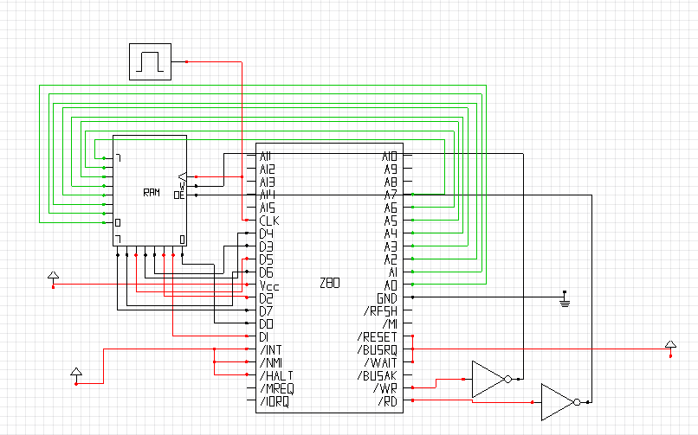

* 1. Explore the menu options available in the Z80 design environment.
  2. Review the Z80 architecture in the Z80 manual (pg 1-10).
  3. Review the Z80 instructions used in the following code segment. The relevant page numbers are indicated below the code.

1. Store the following code in memory and save the file in a memory file named Myprog1

0000 3A0900 LD A, (number) ; Loads A with the contents of number

0003 C60A ADD A,10 ; Adds 10(decimal) to A i.e. A = A+10

0005 320A00 LD (Result), A ; Stores the result at Result

0008 76 Halt

0009 4A Number: DEFB 74

000A 00 Result: DEFB 0

Show memory contents and the circuit status at the end of each instruction executed,